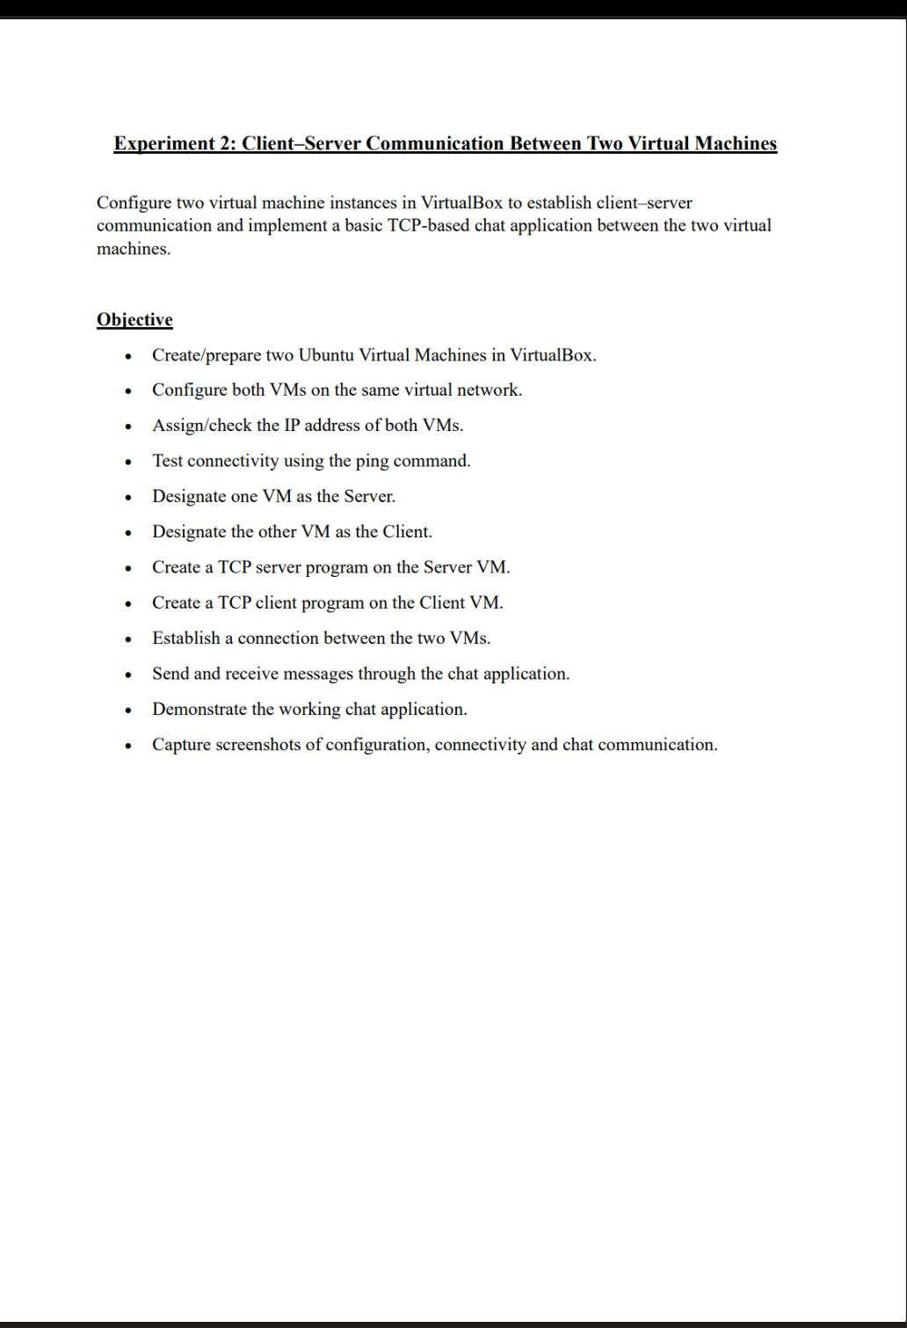
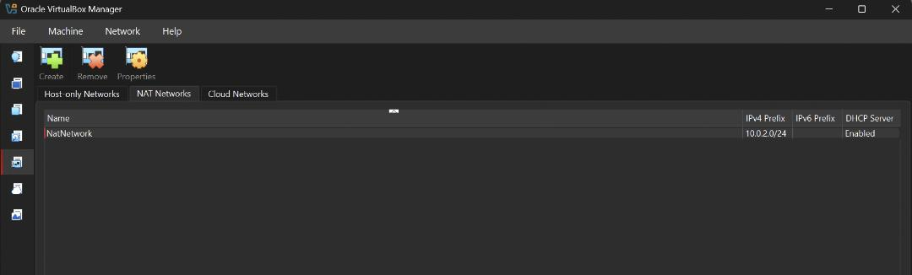
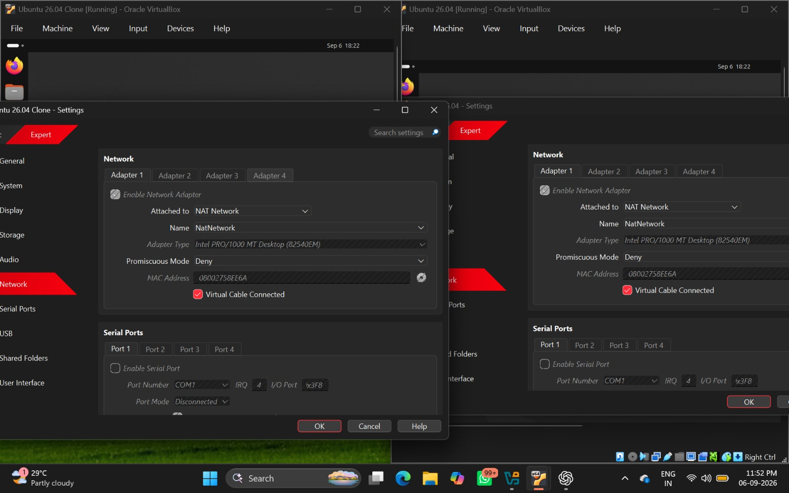
- Creating and preparing two Ubuntu Virtual Machines in VirtualBox.

- Configure both VMs on the same virtual network.

- Checking the IP address of both VMs.
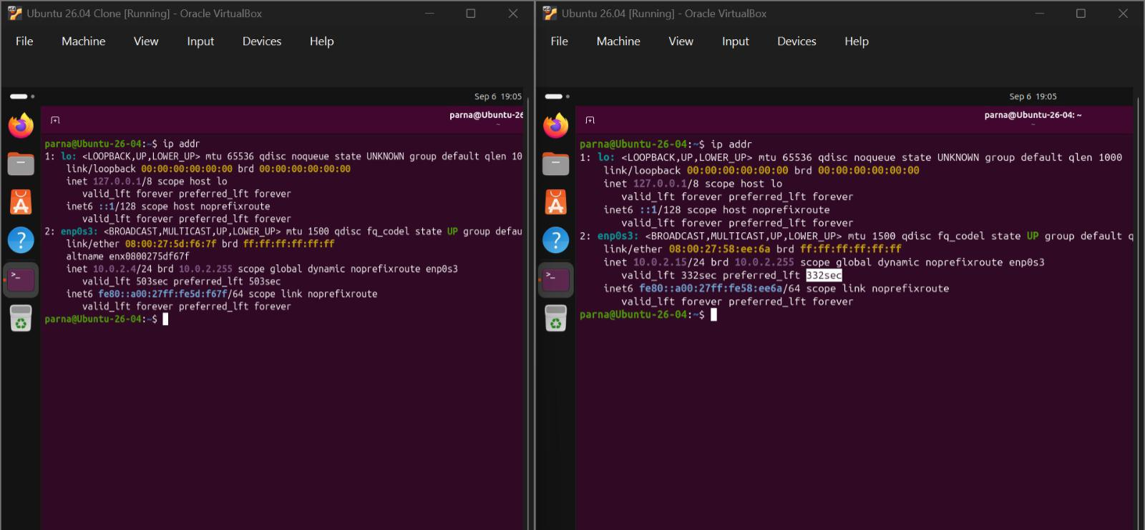

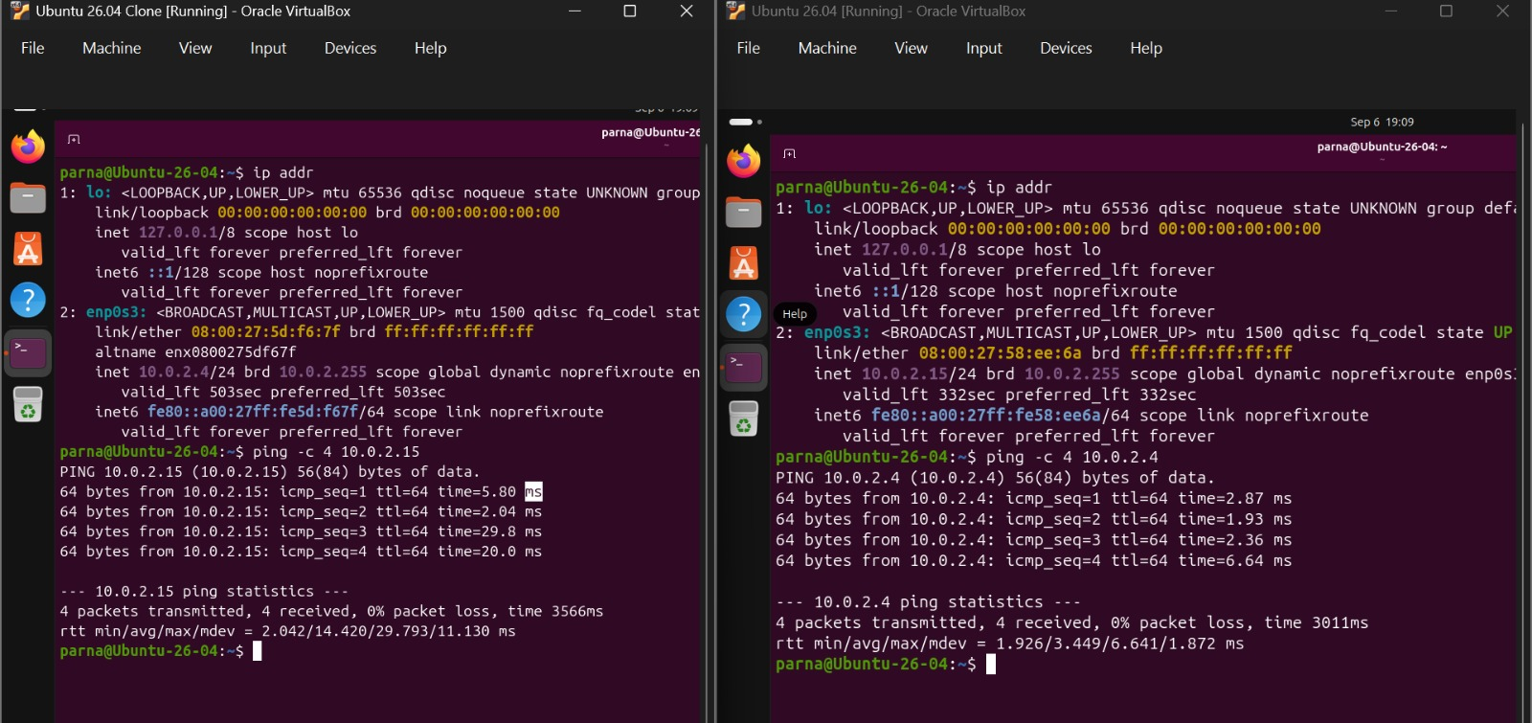
- Testing connectivity using the ping command
- Designate one VM as the Server.
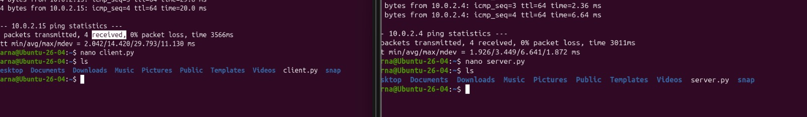
- Designate the other VM as the Client

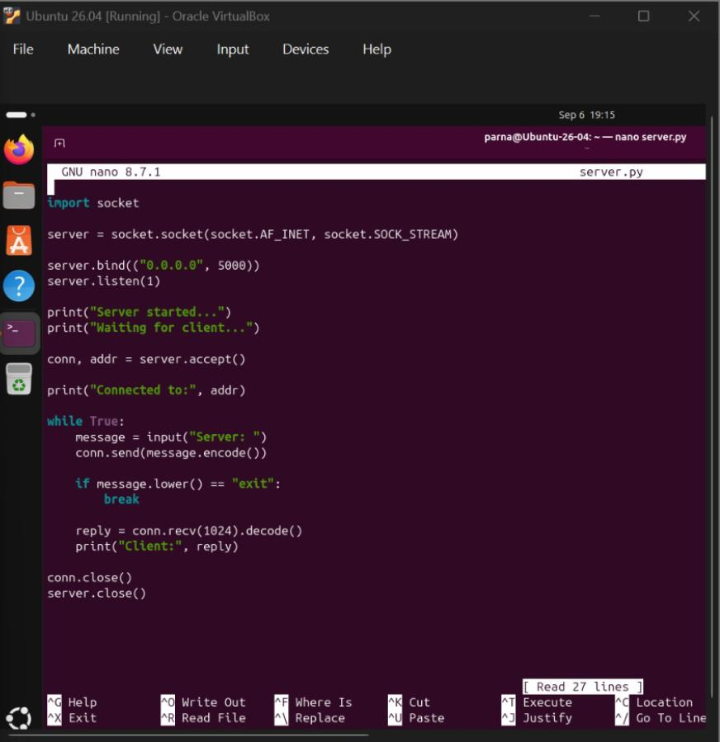
- Create a TCP server program on the Server VM
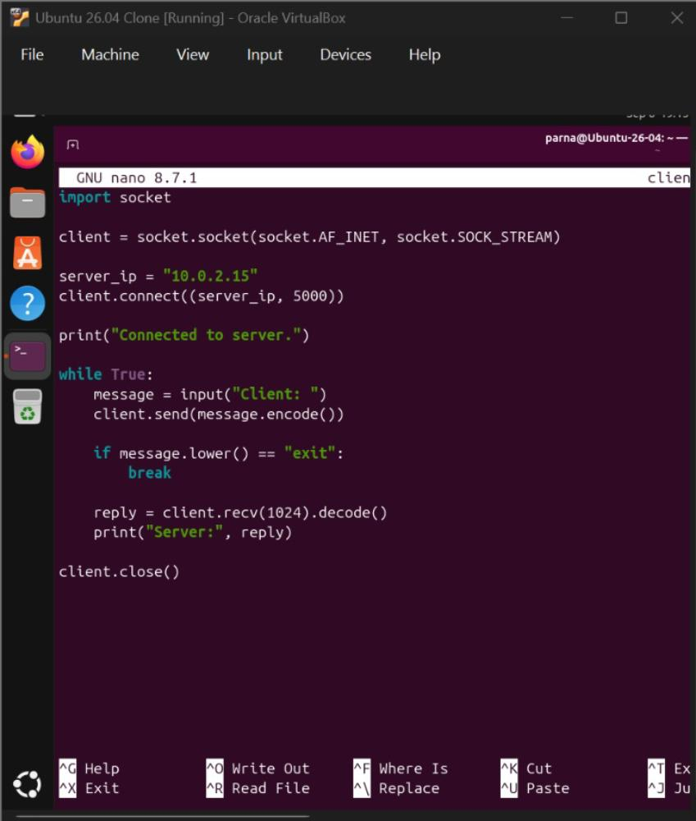
- Create a TCP client program on the Client VM

- Establishing a connection between the two VMs.
- Sending and receiving messages through the chat application.
